Module Assembly - TopCoder NodeJS Modify Answer and Delete Answer API Deployment Guide

Revision History
Author | Revision Number | Date
isv | 1.0 | 11/04/2014

Deployment Instructions 3
1. Organization of Submission 3
2. Application Setup 3
2.1 Configuration 3
2.2 Build Scripts Setup 3
3. Database Setup 4
4. Deployment Instructions 4
5. Starting 4
6. Verification 4
7. Resource Contact List 7

Deployment Instructions

Organization of Submission

The submission follows directory structure provided below:

docs

Contains this document which is the Deployment Guide for the Module Assembly - TopCoder NodeJS Modify Answer and Delete Answer API assembly.

tc-api

Contains the configuration, libraries, sources for TopCoder Node JS API application developed/updated in the course of this assembly. This directory replicates the application development distribution structure and includes only updated and new files.

Application Setup

The submission is expected to be deployed to the following environment:

JRE 1.7
NodeJS 0.10.21
Informix DS 11.0
Git
Heroku

This assembly was developed against following Git commit hash:

URL: https://github.com/cloudspokes/tc-api.git
Hash: fcfcad739ea6a5736f064e474563de4041a6fb08

Configuration

No new configuration parameters have been defined by this assembly.

Build Scripts Setup

The TopCoder NodeJS API application provides the following commands which are to be used:

- npm install – installs TopCoder NodeJS API application
- npm rebuild – rebuilds TopCoder NodeJS API application
- npm test – runs Mocha-based unit tests.

Database Setup

No changes to existing database schema have been introduced with this assembly.

Deployment Instructions

- Set up necessary infrastructure for TopCoder NodeJS API based on your environment See following page for details (click the link corresponding to your OS):
  - https://github.com/cloudspokes/tc-api/wiki/_pages
- Clone TopCoder NodeJS application from Git repository https://github.com/cloudspokes/tc-api.git to your local machine. See chapters suitable for your local environment at following page for details (click the link corresponding to your OS):
  - https://github.com/cloudspokes/tc-api/wiki/_pages
- Checkout the TopCoder NodeJS application commit referenced by hash specified by section 2 of this guide (use git checkout command)
- Switch to dev branch using git checkout dev command
- Copy the code from tc-api directory of this submission into working copy cloned from Git repository at step above
- Set up environment variables to suit the current environment. See https://github.com/cloudspokes/tc-api/wiki/Configure-Environment-Variables
- Install TopCoder NodeJS API application using npm install command. See chapters suitable for your local environment at https://github.com/cloudspokes/tc-api/wiki/_pages for help (click the link corresponding to your OS)

Starting

- Install the TopCoder NodeJS API application
- Start ActionsHero server instance hosting TopCoder NodeJS API application (see Start Server chapter at page matching your current OS at https://github.com/cloudspokes/tc-api/wiki/_pages)

Verification

- Setup node-jslint tool using command like npm install jslint -g and check formatting for the updated code using commands like:

jslint -nomen actions/srmRoundQuestions.js
jslint -nomen test/test.modifyDeleteAnswers.js
jslint routes.js

There must be no code formatting errors displayed:

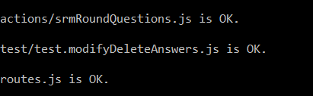

- Run the unit tests using command like:

node_modules/.bin/mocha ./test/test.modifyDeleteAnswers.js

The tests must be executed successfully:

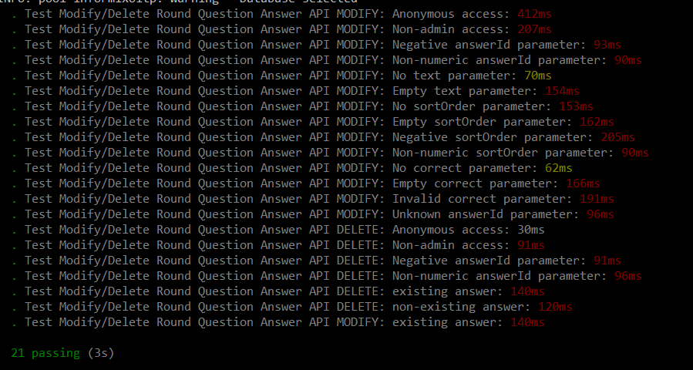

- Deploy application to Heroku by following the instructions at https://github.com/cloudspokes/tc-api/wiki/Heroku-Deployment-Guide

The application must be deployed successfully.

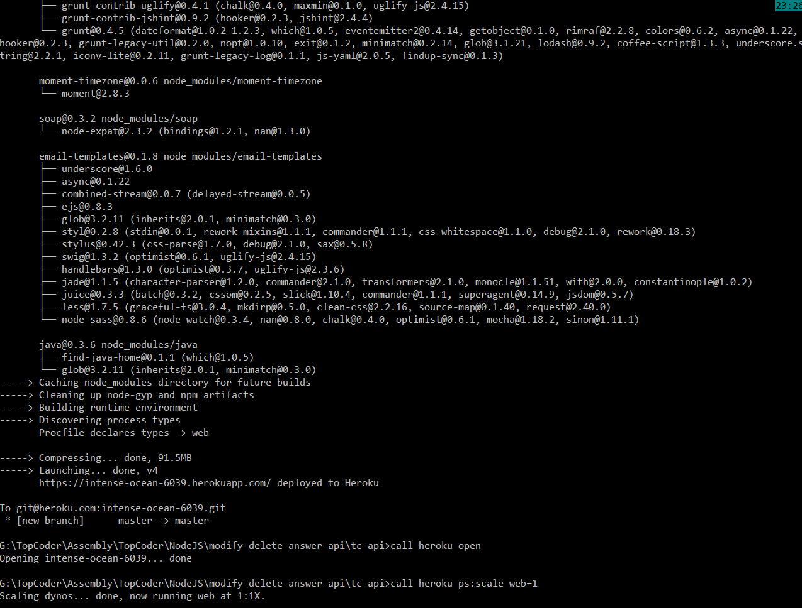

- To verify the API documentation, go to http://apiary.io, register and create own account, open Blueprint Editor and copy the content of tc-api/apiary.apib file from submission to editor and click Save API BluePrint button and after content is saved click Documentation tab.

The API documentation must be displayed successfully.

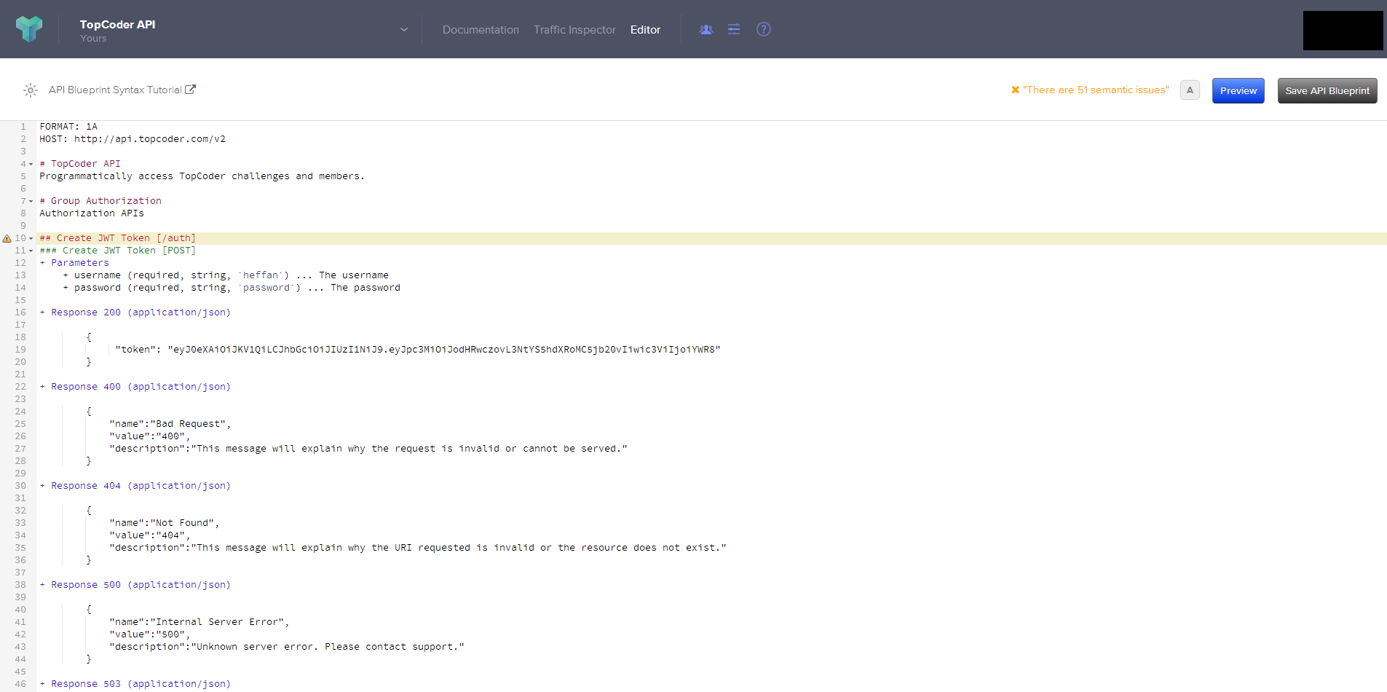

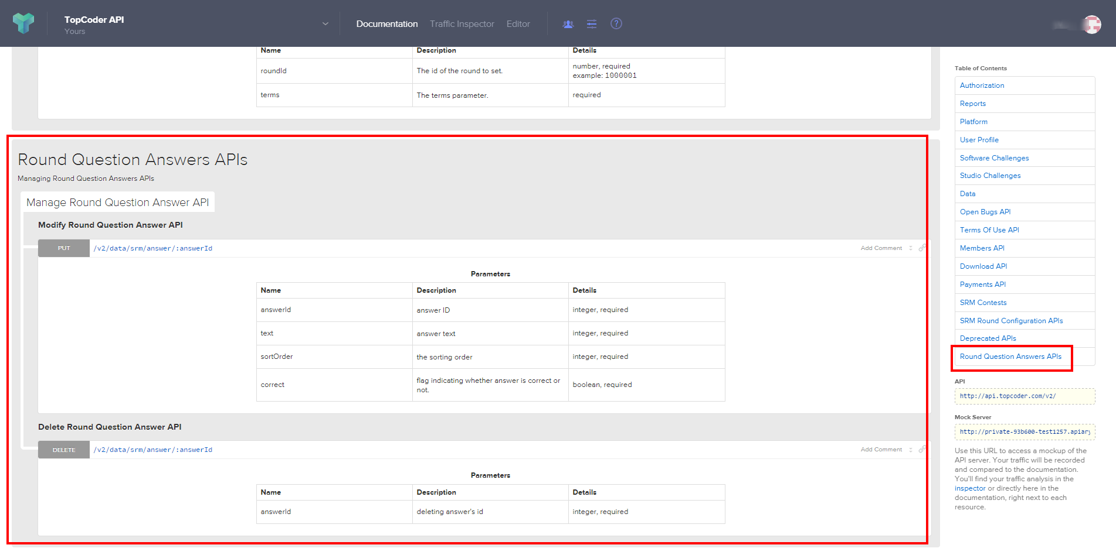

Resource Contact List

Name | Resource Email
isv

